出現這種問題時是因為連線的主機需要憑證

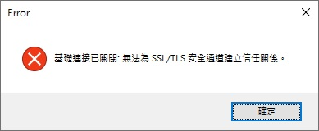

private string GetLastVersion()

{

HttpWebRequest request = (HttpWebRequest)HttpWebRequest.Create(CheckVersionUrl);

request.UserAgent = "Mozilla/4.0 (compatible; MSIE 6.0; Windows NT 5.2; SV1; .NET CLR 1.1.4322; .NET CLR 2.0.50727)";

request.Method = "GET";

request.ContentType = "application/x-www-form-urlencoded";

using (StreamReader sr = new StreamReader(request.GetResponse().GetResponseStream(), Encoding.UTF8))

return sr.ReadToEnd();

}

可以改成下面這樣，就可以忽略憑證的錯誤訊息

private string GetLastVersion()

{

HttpWebRequest request = (HttpWebRequest)HttpWebRequest.Create(CheckVersionUrl);

ServicePointManager.ServerCertificateValidationCallback += new System.Net.Security.RemoteCertificateValidationCallback(ValidateServerCertificate);

request.UserAgent = "Mozilla/4.0 (compatible; MSIE 6.0; Windows NT 5.2; SV1; .NET CLR 1.1.4322; .NET CLR 2.0.50727)";

request.Method = "GET";

request.ContentType = "application/x-www-form-urlencoded";

using (StreamReader sr = new StreamReader(request.GetResponse().GetResponseStream(), Encoding.UTF8))

return sr.ReadToEnd();

}

public static bool ValidateServerCertificate(object sender, X509Certificate certificate, X509Chain chain, SslPolicyErrors sslPolicyErrors)

{

return true;

}